VINSUP SKILL ACADEMY
Coimbatore - 641006

PROJECT DOCUMENTATION REPORT

Retail Sales Analytics Using Excel, SQL, Power BI and Python

Student Name | Abinaya P
Institution | Vinsup Skill Academy
Domain | Retail, Sales & Inventory Analytics
Tools Used | Excel | MySQL | Python | Power BI
Submission Date | April 2026

Dashboard Link
Project Drive Folder:
The project folder contains all deliverables including SQL scripts, Python notebook, Power BI dashboard (.pbix), and segmentation output CSV.

INTRODUCTION

This project focuses on analyzing detailed retail sales data using multiple tools such as Excel, MySQL, Python, and Power BI.
The main purpose is to convert raw data into meaningful insights that help understand business performance.

Phase 1: Objective

The objectives of this project are:
To analyze overall sales performance
To identify top-selling products and categories
To understand customer purchasing behavior
To analyze store-wise and time-based sales trends
To create an interactive dashboard for visualization

Phase 2: Dataset Description

The dataset consists of multiple related tables used in a retail business.
Tables Used:
customers – contains customer details
orders – contains order information
order_items – contains products in each order
products – contains product details
categories – product category information
brands – brand details
stores – store information
stocks – product stock availability
staffs – employee details
.

Phase 3: Tools & Technologies Used
Excel

Used for initial data cleaning
Removed missing values and duplicates
Formatted data for further processing
MySQL
Used to store data in relational format
Performed SQL queries using joins and aggregations
Extracted useful information like total sales and product performance
Python
Used for Exploratory Data Analysis (EDA)
Libraries used: Pandas, NumPy, Matplotlib
Identified trends, patterns, and outliers
Power BI
Used to create interactive dashboards
Visualized key metrics using charts and graphs
Enabled filtering and user interaction

Phase 4 : Problem statement
Organizations often struggle to extract actionable insights from raw
data. This project addresses the following challenges:- Unstructured
and inconsistent data- Lack of centralized database- Difficulty in
identifying customer behavior patterns- Limited visibility into sales and
inventory performance

Phase 5 : Key Business Problems

*Lack of Customer Insights :
*Businesses do not clearly understand customer behavior
*Difficult to identify loyal vs inactive customers
*No segmentation for targeted marketing

*Solution :
*Applied RFM (Recency, Frequency, Monetary) analysis
*Used clustering (K-Means) to segment customers

Phase 6: Poor Sales Performance Visibility

* No clear view of total revenue trends
* Difficult to identify top-performing products
*Lack of monthly/seasonal analysis

Solution :
*Created sales trend analysis (daily/monthly/yearly)
*Built KPIs such as Total Revenue and Average Order Value
Phase 6 Inventory Management Issues-

*Overstocking or understocking products
* No alerts for low stock items
* Inefficient stock distribution across stores
Solution :
*Analyzed stock levels using stocks table
*Created low-stock alerts (threshold-based)
*Compared stock vs sales performance

Phase 7: Data Quality Issues

*Missing values (ZIP codes, dates)
* Duplicate records
*inconsistent formats
Solution :
*Data cleaning in Excel
* Standardized formats-
*Validated foreign key relationships

Phase 8: Inefficient Decision-Making-

*Decisions based on assumptions, not data
* No centralized reporting system
Solution :
* Built Power BI dashboards
*Enabled real-time insights using visuals
*Provided interactive filtering (slicers)

Phase 9: Lack of Staff & Store Performance Analysis

* No clarity on which store performs better-
* Staff productivity not tracked
Solution :
* Analyzed revenue per store-
*Evaluated staff performance using order handling data

Phase 10: Exploratory Data Analysis

* Identified trends and patterns
* Compared categories and brands
*Detected anomalie

Phase 11: Business Impact

Before Analysis :
*Limited visibility
*Reactive decision-making
* Poor customer targeting

After Analysis :
* Data-driven decisions-
* Improved customer retention strategies-
*Better inventory planning-
*Increased operational efficiency

Phase 12: Recommendations

*Focus marketing on high-value customers
* Provide offers to at-risk customers
* Maintain optimal stock levels
*Monitor sales trends regularly
*Use dashboards for continuous decision-making

Dashboard

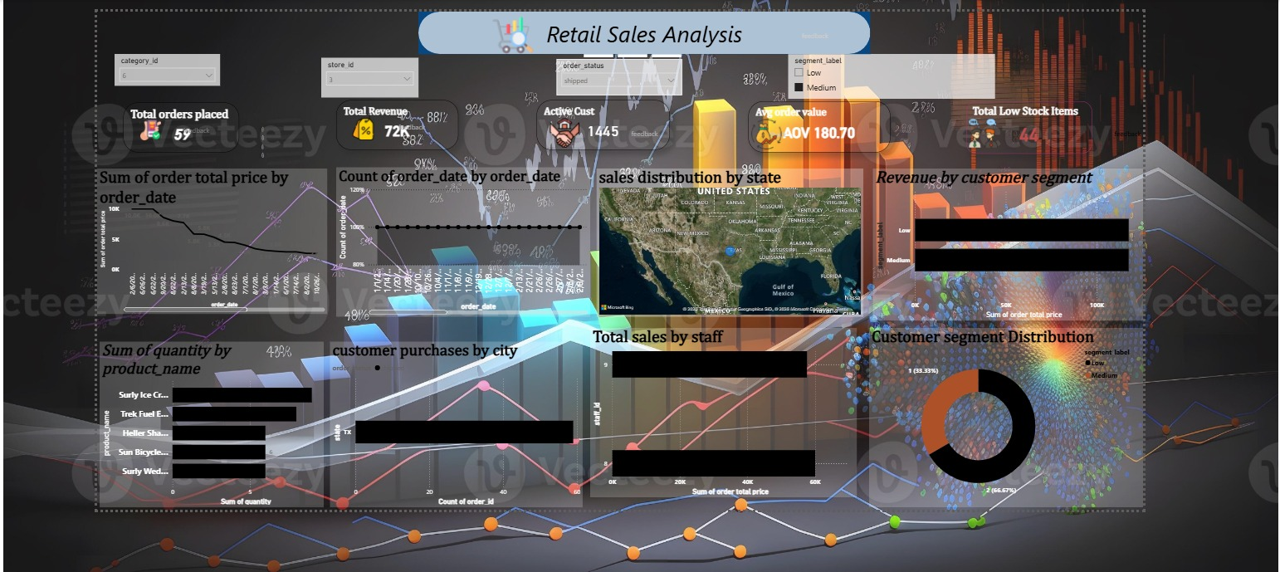

Phase 13: Conclusion

*Focus marketing on high-value customers
* Provide offers to at-risk customers
* Maintain optimal stock levels
*Monitor sales trends regularly
*Use dashboards for continuous decision-making

